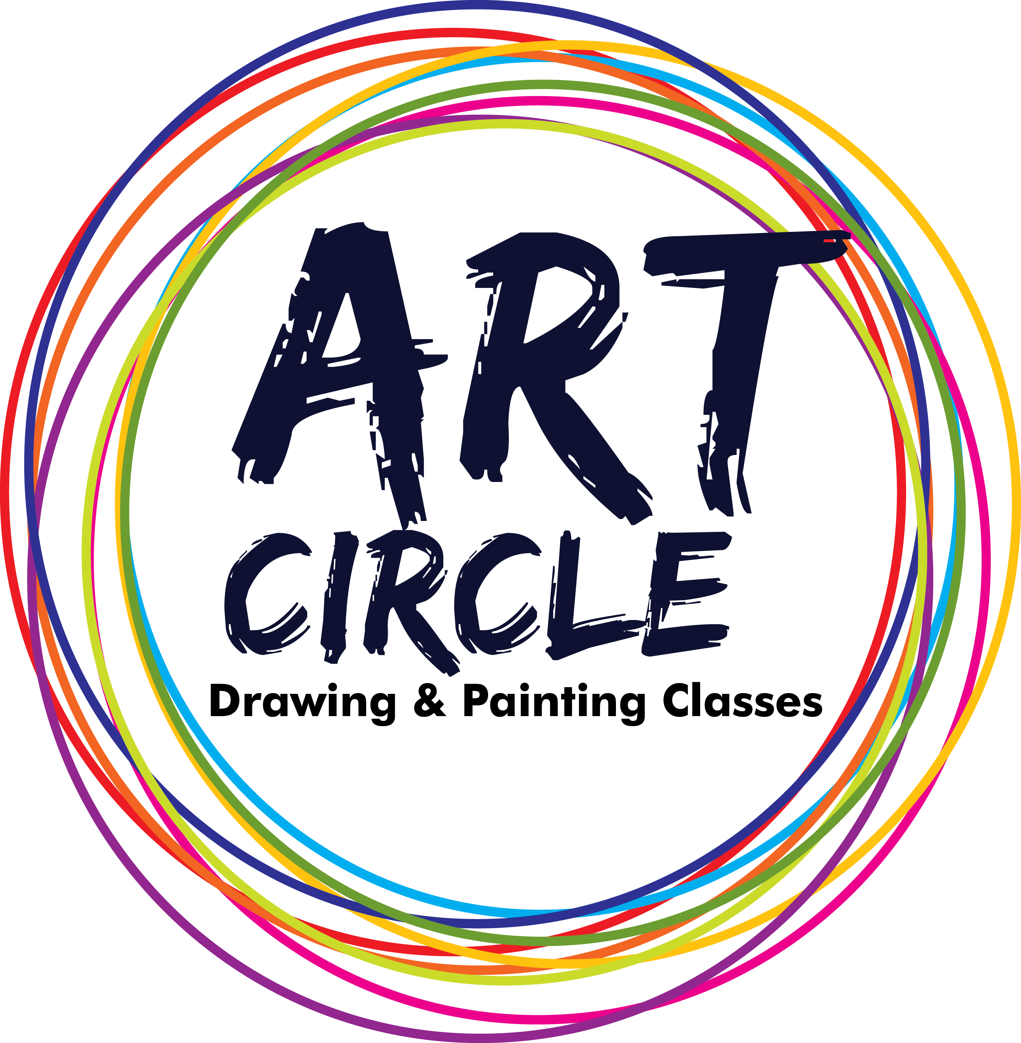 ART CIRCLE ACADEMY
DRAWING & PAINTING Date:

Dear Parents,
We, Art Circle Academy (Drawing and painting) conduct Art classes in Mumbai. We always work on student’s aspiration and to encourage them to improve their Art skills. To make their skills stronger and stronger in field of Art, we are planning to have an Art competition. The competition is to be conducted on Sunday, 07th Feb 2016 at Maharashtra Nature Park, Dharavi. We are expecting full support from the parents who can actually help us to put forward their children’s skills.
This competition is restricted for student of Art Circle Academy only. Request you to have maximum attendance for the competition.

Below is the Program agenda.(Students are requested to report 30 minutes before the competition)
Program Agenda
From | To | Task
10.00 am - | 12.00 pm | Art competition
12.00 pm – | 01.00 pm | Entertainment and fun
01.00 pm – | 01.30 pm | Result declaration and prize distribution
Venue: Maharashtra Nature Park, Opposite Dharavi Bus Depot, Dharavi, Mumbai-400017
Entry Rules & Conditions
1. This competition will be only for the student of an Art Circle Academy.
2. Drawing paper, will be providing by organisation, rather than this all required material students should bring with them.
3. Full name, age, (Day/month/year) and full address including phone and email must be on the back of the painting.
4. Note: Student should bring Drawing Board with them.
5. Students can use the pencil colour, water colour, crayons, oil pastels etc for the painting.
6. Do not include any words or descriptions in the painting.
7. Fees for the competition are Rs-250.
8.This competition is divided in to 4 groups are as follows:
i)Jr. KG & Sr.KG ii)1^{st,}, & 2nd standard
iii)3rd ,& 4th , standard iv)5th ,6th ,7th ,& above
9. The result of competition will be declared by the honourable person in art field.
10. “Art Circle Academy” holds all the rights reserved.

Thanking you. Regards,

U. R. PATIL
President of Art circle Academy

